1. Write a program to create a RDD with 5 partitions for below array and print the number of partitions

data = [1,2,3,4,5,6,7,8,9,10,11,12]
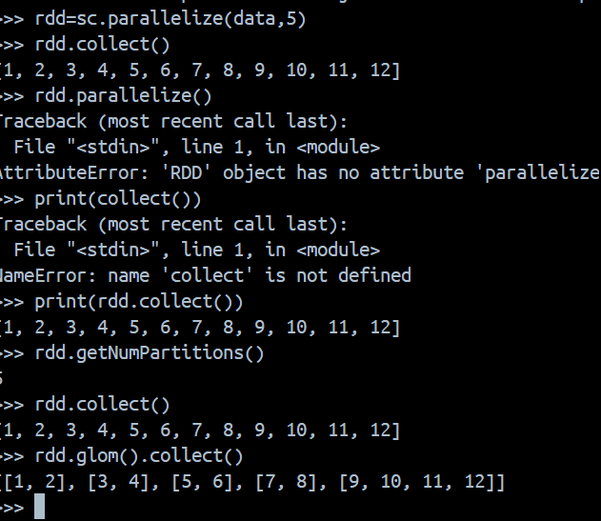

2. Copy below data in a text file and create an RDD and count the number of records

1827|2008-01-01|WE|1|JAN|1|2008|TRUE
1828|2008-01-02|TH|1|JAN|1|2008|FALSE
1829|2008-01-03|FR|1|JAN|1|2008|FALSE
1830|2008-01-04|SA|2|JAN|1|2008|FALSE
1831|2008-01-05|SU|2|JAN|1|2008|FALSE
1832|2008-01-06|MO|2|JAN|1|2008|FALSE
1833|2008-01-07|TU|2|JAN|1|2008|FALSE
1834|2008-01-08|WE|2|JAN|1|2008|FALSE
1835|2008-01-09|TH|2|JAN|1|2008|FALSE
1836|2008-01-10|FR|2|JAN|1|2008|FALSE
1837|2008-01-11|SA|3|JAN|1|2008|FALSE
1838|2008-01-12|SU|3|JAN|1|2008|FALSE
1839|2008-01-13|MO|3|JAN|1|2008|FALSE
1840|2008-01-14|TU|3|JAN|1|2008|FALSE
1841|2008-01-15|WE|3|JAN|1|2008|FALSE
1842|2008-01-16|TH|3|JAN|1|2008|FALSE
1843|2008-01-17|FR|3|JAN|1|2008|FALSE
1844|2008-01-18|SA|4|JAN|1|2008|FALSE
1845|2008-01-19|SU|4|JAN|1|2008|FALSE
1846|2008-01-20|MO|4|JAN|1|2008|FALSE
1847|2008-01-21|TU|4|JAN|1|2008|FALSE
1848|2008-01-22|WE|4|JAN|1|2008|FALSE
1849|2008-01-23|TH|4|JAN|1|2008|FALSE
1850|2008-01-24|FR|4|JAN|1|2008|FALSE
1851|2008-01-25|SA|5|JAN|1|2008|FALSE
1852|2008-01-26|SU|5|JAN|1|2008|FALSE
data = [ "1827|2008-01-01|WE|1|JAN|1|2008|TRUE", "1828|2008-01-02|TH|1|JAN|1|2008|FALSE", "1829|2008-01-03|FR|1|JAN|1|2008|FALSE", "1830|2008-01-04|SA|2|JAN|1|2008|FALSE", "1831|2008-01-05|SU|2|JAN|1|2008|FALSE", "1832|2008-01-06|MO|2|JAN|1|2008|FALSE", "1833|2008-01-07|TU|2|JAN|1|2008|FALSE", "1834|2008-01-08|WE|2|JAN|1|2008|FALSE", "1835|2008-01-09|TH|2|JAN|1|2008|FALSE", "1836|2008-01-10|FR|2|JAN|1|2008|FALSE", "1837|2008-01-11|SA|3|JAN|1|2008|FALSE", "1838|2008-01-12|SU|3|JAN|1|2008|FALSE", "1839|2008-01-13|MO|3|JAN|1|2008|FALSE", "1840|2008-01-14|TU|3|JAN|1|2008|FALSE", "1841|2008-01-15|WE|3|JAN|1|2008|FALSE", "1842|2008-01-16|TH|3|JAN|1|2008|FALSE", "1843|2008-01-17|FR|3|JAN|1|2008|FALSE", "1844|2008-01-18|SA|4|JAN|1|2008|FALSE", "1845|2008-01-19|SU|4|JAN|1|2008|FALSE", "1846|2008-01-20|MO|4|JAN|1|2008|FALSE", "1847|2008-01-21|TU|4|JAN|1|2008|FALSE", "1848|2008-01-22|WE|4|JAN|1|2008|FALSE", "1849|2008-01-23|TH|4|JAN|1|2008|FALSE", "1850|2008-01-24|FR|4|JAN|1|2008|FALSE", "1851|2008-01-25|SA|5|JAN|1|2008|FALSE", "1852|2008-01-26|SU|5|JAN|1|2008|FALSE" ]

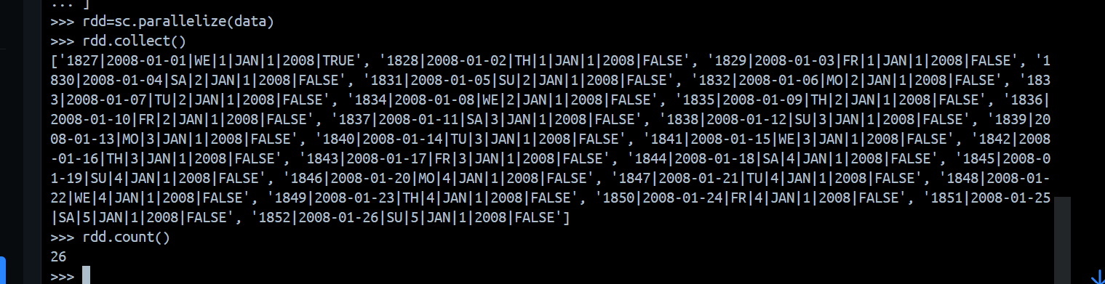
3. Write a program to assign a count to each word given in the paragraph below.

Python Lists allow us to hold items of heterogeneous types. In this article, we will learn how to create a list in Python; access the list items; find the number of items in the list, how to add an item to list; how to remove an item from the list; loop through list items; sorting a list, reversing a list; and many more transformation and aggregation actions on Python Lists.

Expected output should look like

('Python', 2)
('Lists', 1)
('allow', 1)
('us', 1)
('to', 5)
('hold', 1)
('items', 2)
('of', 2)
('heterogeneous', 1)

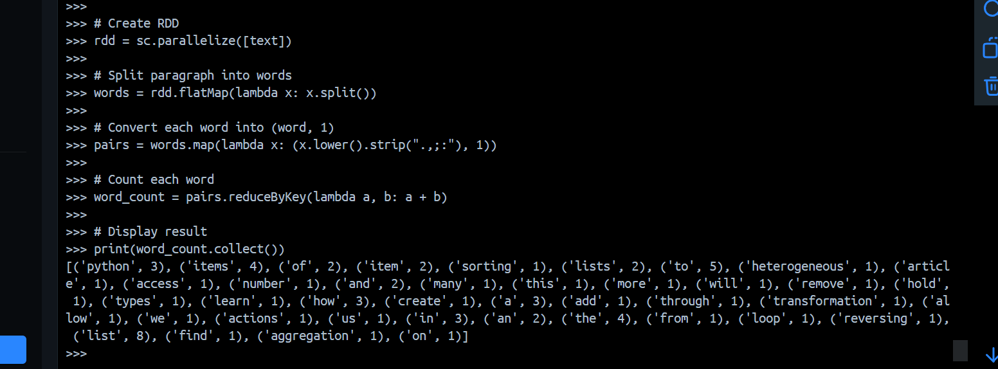

4. Write a program and sql for followings
- Register dataframe as view named as Users
- Return the details for only those users where salary is more than 3000

data = [("James","","Smith","36636","M",3000),
("Michael","Rose","","40288","M",4000),
("Robert","","Williams","42114","M",4000),
("Maria","Anne","Jones","39192","F",4000),
("Jen","Mary","Brown","","F",-1)
]

schema = StructType([ \
StructField("firstname",StringType(),True), \
StructField("middlename",StringType(),True), \
StructField("lastname",StringType(),True), \
StructField("id", StringType(), True), \
StructField("gender", StringType(), True), \
StructField("salary", IntegerType(), True) \
])

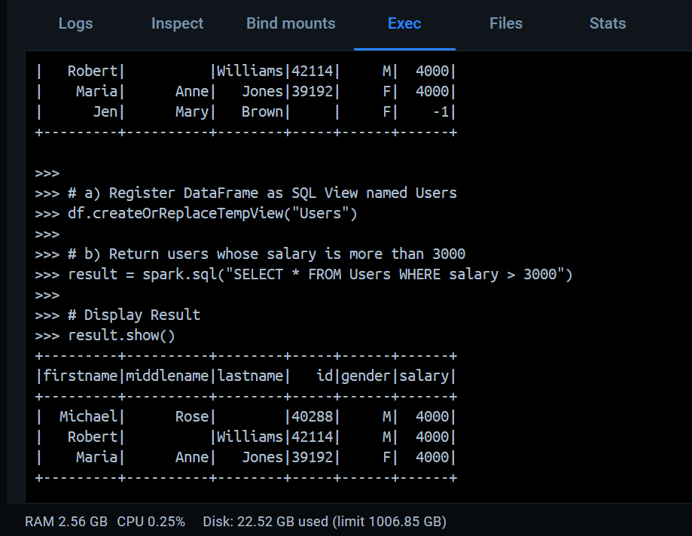
5. Write a program and sql for followings
- Register dataframe as view named as Users
- Write a sql to return 'firstname' when 'lastname' is Rose

structureData = [
(("James","","Smith"),"36636","M",3100),
(("Michael","Rose",""),"40288","M",4300),
(("Robert","","Williams"),"42114","M",1400),
(("Maria","Anne","Jones"),"39192","F",5500),
(("Jen","Mary","Brown"),"","F",-1)
]
structureSchema = StructType([
StructField('name', StructType([
StructField('firstname', StringType(), True),
StructField('middlename', StringType(), True),
StructField('lastname', StringType(), True)
])),
StructField('id', StringType(), True),
StructField('gender', StringType(), True),
StructField('salary', IntegerType(), True)
])
# Create Data
>>> structureData = [
... (("James", "", "Smith"), "36636", "M", 3100),
... (("Michael", "Rose", ""), "40288", "M", 4300),
... (("Robert", "", "Williams"), "42114", "M", 1400),
... (("Maria", "Anne", "Jones"), "39192", "F", 5500),
... (("Jen", "Mary", "Brown"), "", "F", -1)
... ]
>>>
>>> # Define Schema
>>> structureSchema = StructType([
... StructField("name", StructType([
... StructField("firstname", StringType(), True),
... StructField("middlename", StringType(), True),
... StructField("lastname", StringType(), True)
... ])),
... StructField("id", StringType(), True),
... StructField("gender", StringType(), True),
... StructField("salary", IntegerType(), True)
... ])
>>> df = spark.createDataFrame(structureData, structureSchema)
>>> df.show(truncate=False)
+--------------------+-----+------+------+
|name |id |gender|salary|
+--------------------+-----+------+------+
|{James, , Smith} |36636|M |3100 |
|{Michael, Rose, } |40288|M |4300 |
|{Robert, , Williams}|42114|M |1400 |
|{Maria, Anne, Jones}|39192|F |5500 |
|{Jen, Mary, Brown} | |F |-1 |
+--------------------+-----+------+------+

>>> df.createOrReplaceTempView("Users")
>>>
>>> result = spark.sql("""
... SELECT name.firstname
... FROM Users
... WHERE name.lastname = 'Rose'
... """)
>>>
>>> result.show()
+---------+
|firstname|
+---------+
+---------+

>>>

